Tài liệu bổ trợ bài tập lớn – Phần 3
Lab1
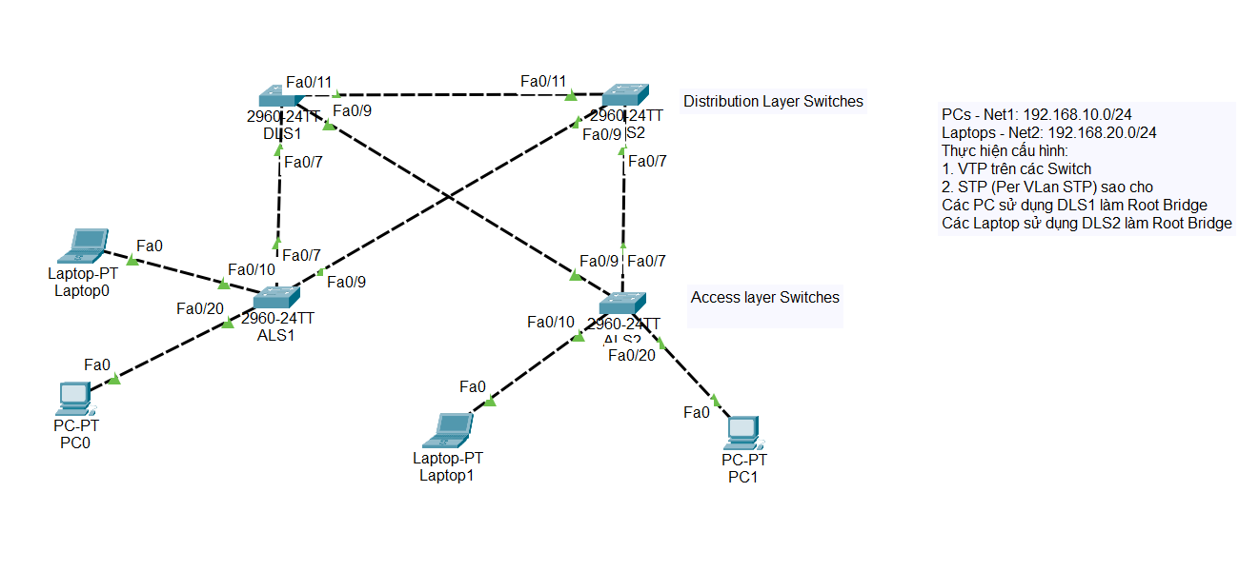
Cấu hình DLS1
enable
configure terminal
hostname DLS1
vtp version 2
vtp mode server
vtp domain MMT.COM
vtp password 123
interface range fa0/7, fa0/9, fa0/11
switchport mode dynamic desirable
exit
vlan 100
name USER_VLAN
exit
vlan 200
name IT_VLAN
exit
spanning-tree vlan 100 root primary
spanning-tree vlan 200 root primary
end
write memory
Cấu hình DLS2
enable
configure terminal
hostname DLS2
vtp version 2
vtp mode server
vtp domain MMT.COM
vtp password 123
interface range fa0/7, fa0/9, fa0/11
switchport mode dynamic desirable
exit
spanning-tree vlan 100 root secondary
spanning-tree vlan 200 root secondary
end
write memory
Cấu hình ALS1
enable
configure terminal
hostname ALS1
vtp version 2
vtp mode server
vtp domain MMT.COM
vtp password 123
interface range fa0/7, fa0/9
switchport mode dynamic auto
exit
interface fa0/7
spanning-tree vlan 200 cost 40
exit
interface fa0/10
switchport access vlan 200
switchport mode access
exit
interface fa0/20
switchport access vlan 100
switchport mode access
exit
end
write memory
Cấu hình ALS2
enable
configure terminal
hostname ALS2
vtp version 2
vtp mode server
vtp domain MMT.COM
vtp password 123
interface range fa0/7, fa0/9
switchport mode dynamic auto
exit
interface fa0/9
spanning-tree vlan 200 cost 40
exit
interface fa0/10
switchport access vlan 200
switchport mode access
exit
interface fa0/20
switchport access vlan 100
switchport mode access
exit
end
write memory
Lab2
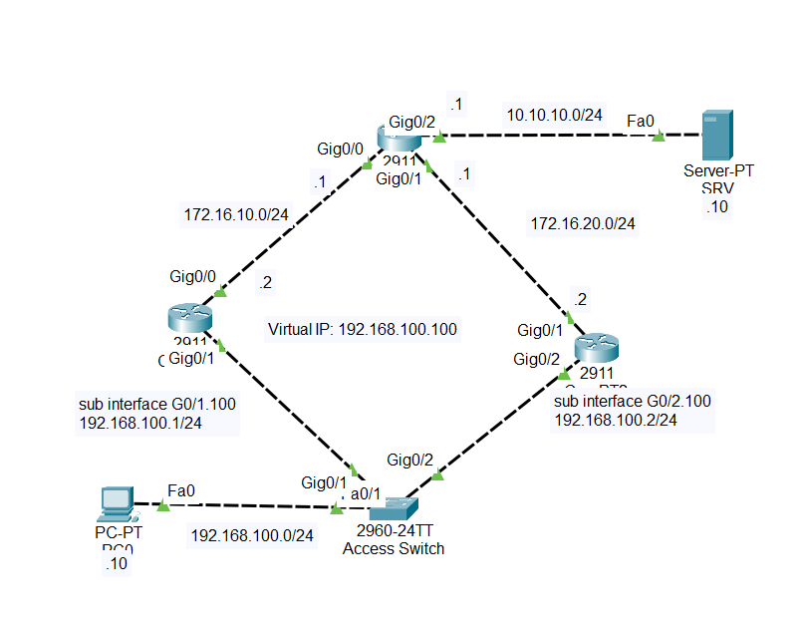
Cấu hình DLS1
enable
configure terminal
hostname DLS1
vtp version 2
vtp mode server
vtp domain MMT.COM
vtp password 123
interface range fa0/7, fa0/9, fa0/11
switchport mode dynamic desirable
exit
vlan 100
name USER_VLAN
exit
vlan 200
name IT_VLAN
exit
spanning-tree vlan 100 root primary
spanning-tree vlan 200 root primary
end
write memory
Cấu hình DLS2
enable
configure terminal
hostname DLS2
vtp version 2
vtp mode server
vtp domain MMT.COM
vtp password 123
interface range fa0/7, fa0/9, fa0/11
switchport mode dynamic desirable
exit
spanning-tree vlan 100 root secondary
spanning-tree vlan 200 root secondary
end
write memory
Cấu hình ALS1
enable
configure terminal
hostname ALS1
vtp version 2
vtp mode server
vtp domain MMT.COM
vtp password 123
interface range fa0/7, fa0/9
switchport mode dynamic auto
exit
interface fa0/7
spanning-tree vlan 200 cost 40
exit
interface fa0/10
switchport access vlan 200
switchport mode access
exit
interface fa0/20
switchport access vlan 100
switchport mode access
exit
end
write memory
Cấu hình ALS2
enable
configure terminal
hostname ALS2
vtp version 2
vtp mode server
vtp domain MMT.COM
vtp password 123
interface range fa0/7, fa0/9
switchport mode dynamic auto
exit
interface fa0/9
spanning-tree vlan 200 cost 40
exit
interface fa0/10
switchport access vlan 200
switchport mode access
exit
interface fa0/20
switchport access vlan 100
switchport mode access
exit
end
write memory
Cấu hình ALS (Access Switch)
enable
configure terminal
hostname ALS
vlan 100
name VLAN100
exit
interface range fa0/1 - 10
switchport access vlan 100
switchport mode access
exit
interface g0/1
switchport mode trunk
exit
interface g0/2
switchport mode trunk
exit
end
write memory
Cấu hình CoreRT1
enable
configure terminal
hostname CoreRT1
interface g0/0
ip address 172.16.10.2 255.255.255.0
no shutdown
exit
interface g0/1
no shutdown
exit
interface g0/1.100
description VLAN 100
encapsulation dot1Q 100
ip address 192.168.100.1 255.255.255.0
standby 1 ip 192.168.100.100
standby 1 priority 105
standby 1 track g0/0
standby 1 preempt
exit
router ospf 1
network 172.16.10.0 0.0.0.255 area 0
network 192.168.100.0 0.0.0.255 area 0
exit
end
write memory
Cấu hình CoreRT2
enable
configure terminal
hostname CoreRT2
interface g0/1
ip address 172.16.20.2 255.255.255.0
no shutdown
exit
interface g0/2
no shutdown
exit
interface g0/2.100
description VLAN 100
encapsulation dot1Q 100
ip address 192.168.100.2 255.255.255.0
standby 1 ip 192.168.100.100
standby 1 priority 100
standby 1 track g0/1
standby 1 preempt
exit
router ospf 1
network 172.16.20.0 0.0.0.255 area 0
network 192.168.100.0 0.0.0.255 area 0
exit
end
write memory
Cấu hình ToISP
enable
configure terminal
hostname ToISP
interface g0/0
ip address 172.16.10.1 255.255.255.0
no shutdown
exit
interface g0/1
ip address 172.16.20.1 255.255.255.0
no shutdown
exit
interface g0/2
ip address 10.10.10.1 255.255.255.0
no shutdown
exit
router ospf 1
network 172.16.10.0 0.0.0.255 area 0
network 172.16.20.0 0.0.0.255 area 0
network 192.168.100.0 0.0.0.255 area 0
exit
end
write memory

